Vlad Predovic

IE 415 Winter 2015

Homework #1

Problem 1:

a)



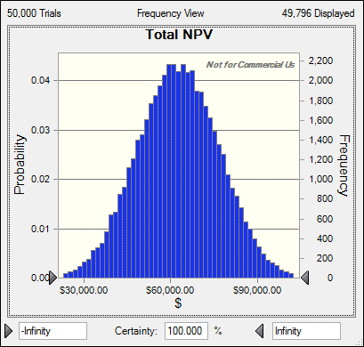b)



Problem 1: c)



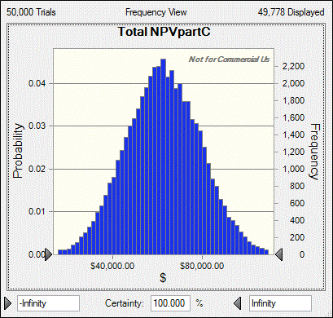

Problem 2:

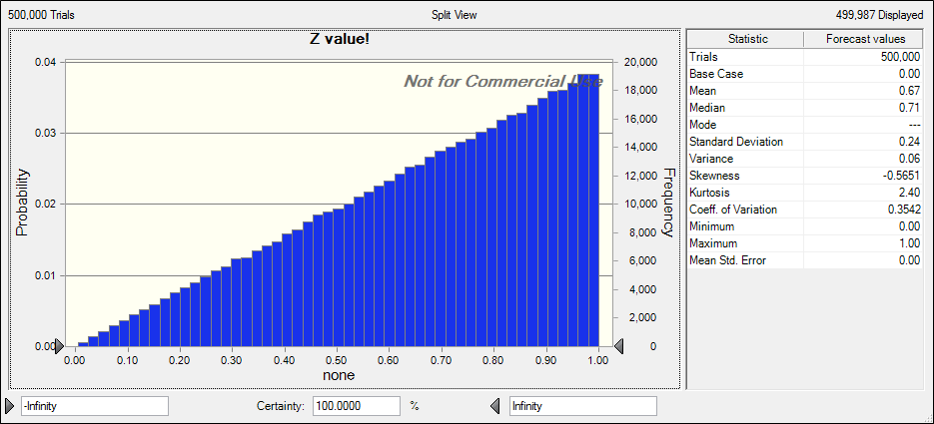

Problem 3:

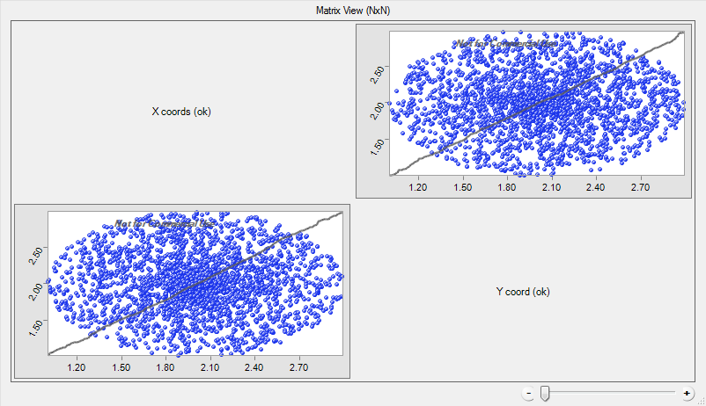

ii. The concentration of points is greatest near the center of the plot. Primarily around the point (2,2)

Problem 4:

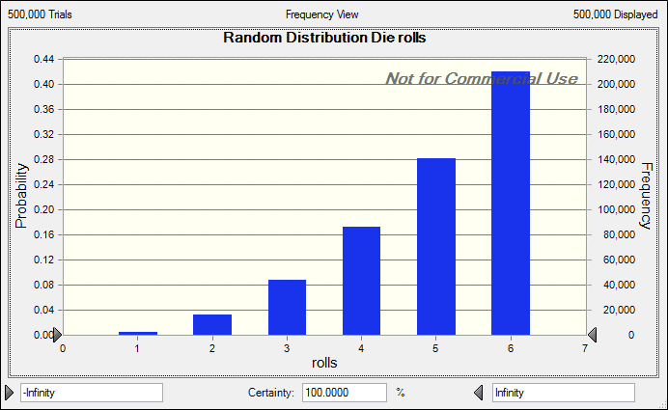

Problem 6:  
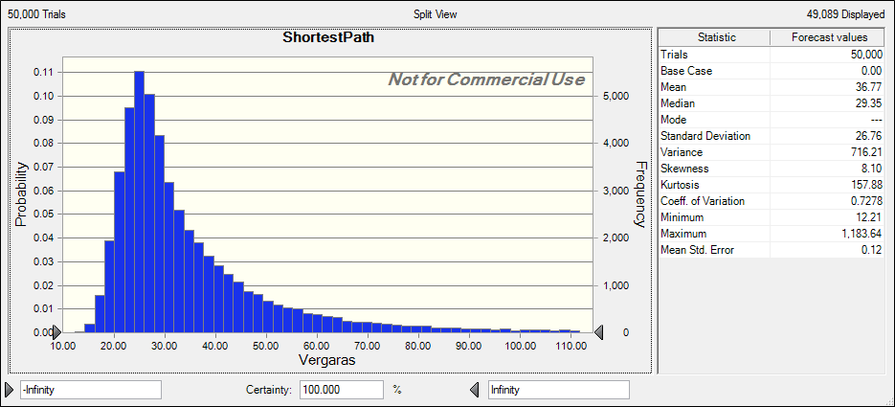

Problem 7:

|  |  |
| --- | --- |
| Forecast: Integral |  |
| Statistic | Forecast values |
| Trials | 1,000,000 |
| Base Case | 5.54 |
| Mean | 6.49 |
| Median | 6.28 |
| Mode | '--- |
| Standard Deviation | 1.17 |
| Variance | 1.38 |
| Skewness | 0.2731 |
| Kurtosis | 1.58 |
| Coeff. of Variation | 0.1811 |
| Minimum | 5.03 |
| Maximum | 8.38 |
| Mean Std. Error | 0 |